Robert Wright & Loghan Flanders
December 12th, 2025

Project Description
This final project implements an automated water cooler-controlled system using our Arduino Mega 2560 as the controller. The system monitors environmental conditions and systems safety parameters to control airflow and ventilation automatically. It is meant to be designed taround a finite state machine with four operating states. Disabled, idle, running, and error. The cooler continuoursly monitors temperature, humidity, and water levels. Based on these various inputs, it controls a fan motor and ventilation damper (mt stepper motor) while providing real-time feedback though LEDs and LCD display, and serial logging with timestamps. Safety and user control are enforced through physical push buttons and error handling logic.
Our project’s system states in more detail are as they go. Disabled (DIS): System is still powered but inactive. Fan is off, sensors are not being monitored actively, and the LCD indicates the system is off. Idle (IDLE): The system monitors the temperature, humidity, water level, and vent position. Fan remains off unless the temperature exceeds the upper threshold. Running (RUN): Fan is activated when the temperature exceeds the defined high threshold. The vent position is adjusted, and the sensor data is logged periodically. Error (ERR): This state is triggered when water levels fall below a safe threshold. The fan is disabled, a warning is displayed on the LCD, and the system awaits a reset from the user.

Component Details
The components used in this lab were listed in the project’s directions and now will be explained in more detail. The main component is our Arduino. The Arduino Mega 2560 serves as the main controller. It executes the state machine logic, reads the data from the sensors, controls actuators, and logs the system events. The LCD Display provides real-time system feedback, displaying the current state, temperature, humidity, and error messages. The I2C interface we use reduces pin usage and simplifies the wiring, I can advocate that my messy wiring would have been worse without the I2C pack. The DHT!! Temperature and Humidity sensor measures the ambient temperature and humidity, as the name suggests. These values are used to determine transitions between idle and Running states. If invalid data is detected, safe fallback values and applied. The Water Level Sensor (Analog input) is connected to an ADC channel and continuously monitored. If the water levels drop below a predefined threshold, the system immediately transitions to the Error State to prevent damage. The Fan Motor provides airflow for cooling. It is controlled digitally through a transistor, 2N2222 from our kit, to allow safe current handling. A flyback diode protects the circuit from inductive voltage spikes. Next is the Ventilation Control (Stepper Motor), which controls the ventilation damper position. Its position is adjusted based on a potentiometer input, allowing for precise airflow regulation. The motor is driven using a standard stepper control sequence. The Potentiometer provides an analog input that sets the target vent position. This allows for manual adjustment of airflow while the system is running to idle. It can also be used to adjust the display of the LCD. Our push buttons provide user interaction: The Start button, uses an external interrupt to transition the system from disabled to idle. The stop button forces the system back to disabled from any active state. The third button, the Reset Button, allows recovery from the Error state once water level is restored. Moving on to our state indicators, our LEDs are used to indicate the current state system. Yellow:Disabled. Green: Idle. Blue: Running. Red: Error. The RTC DS3231 or the Real-Time clock is a module timestamp system of events. Logged data is outputted over the serial interface, providing a time-stamped activity log for debugging and verification. Lastly is the Serial interface; the serial monitor outputs system logs including state transitions, sensor updates, and error conditions. This aids debugging and demonstrates system behavior during operation.

System Overview and Constraints
The system operates at % volts logic levels provided by our Arduino. Motors are driven through appropriate driver circuitry to avoid exceeding current limits of the microcontroller. Temperature thresholds are constrained between 22 Celsius and 25 Celsius, ensuring safe and efficient operation.
Water level monitoring is enforced as a safety constraint; the system cannot operate without sufficient water. Vent movement is limited to a defined range to prevent mechanical damage. Sensor readings are rate-limited to reduce unnecessary processing and LCD flicker. Overall, the design emphasizes safety, modularity, and clarity, while meeting state machines, register levels, and real-time feedback for corrections.

Project Photos
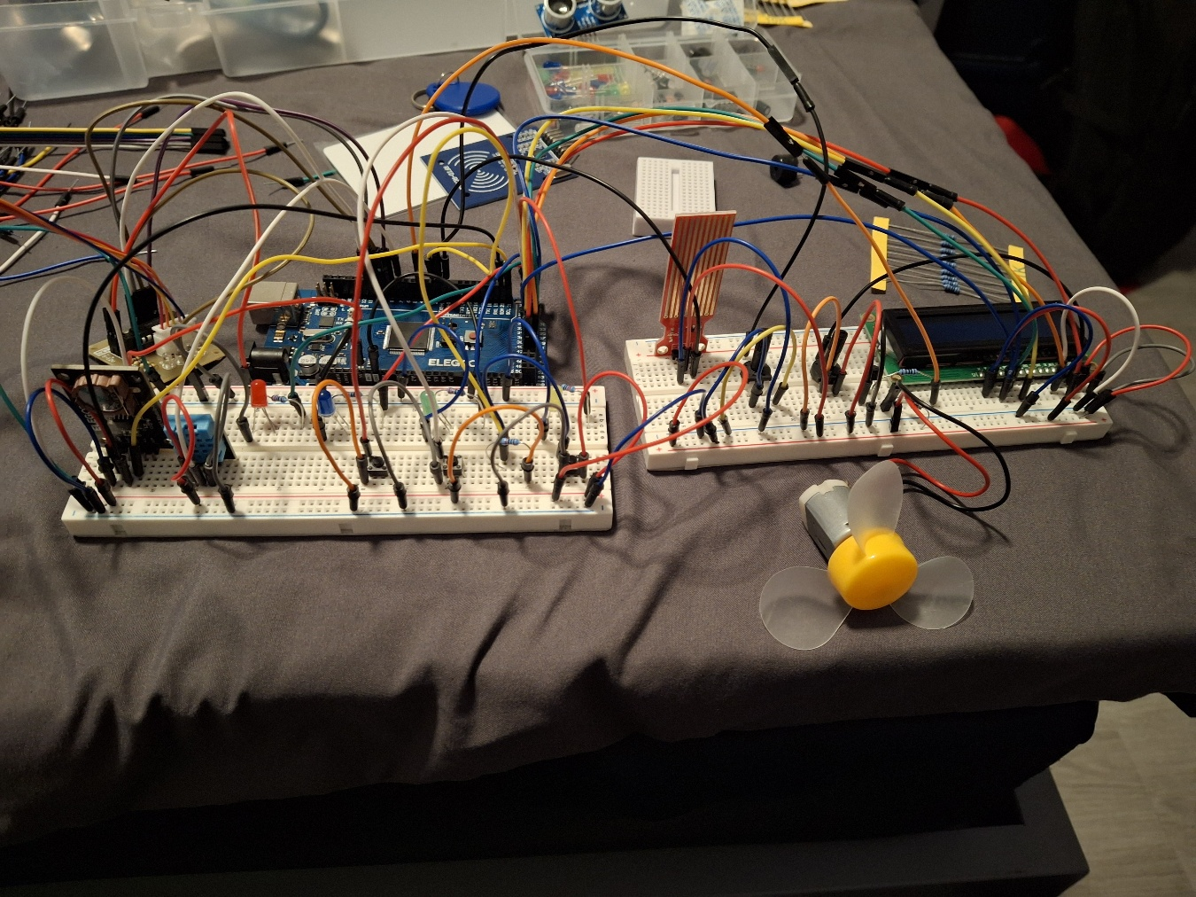

Diagram

Code
// Robert Wright
// Loghan Flanders

#include <Wire.h>
#include <LiquidCrystal_I2C.h>
#include <DHT.h>
#include <RTClib.h>
#include <Stepper.h>
#include <avr/io.h> // for ADC & port names

// State values
#define ST_DIS 0
#define ST_IDLE 1
#define ST_RUN 2
#define ST_ERR 3

// Prototypes
void stDis();
void stIdle();
void stRun();
void stErr();

void pinModeReg(uint8_t pin, uint8_t mode);
void writeReg(uint8_t pin, uint8_t val);
uint8_t readReg(uint8_t pin);
void adcInit();
uint16_t adcRead(uint8_t ch);
void setLED(int s);
void logEvent(const char* msg);
void initPins();
void initPeripherals();
void lcdUpdate(float t, float h, int s);
void getTH(float &t, float &h);
void fanOn();
void fanOff();
void ventCtrl();
uint16_t getWaterLevel();
void startButtonISR();

// UART register helpers (USART0)
void uart_init(unsigned long baud);
void uart_send_char(char c);
void uart_send_str(const char* s);
void uart_send_line(const char* s);

// Pins
#define LED_YELLOW_PIN 22
#define LED_GREEN_PIN 23
#define LED_BLUE_PIN 24
#define LED_RED_PIN 25
#define FAN_MOTOR_PIN 4
#define BUTTON_START_PIN 2
#define BUTTON_STOP_PIN 30
#define BUTTON_RESET_PIN 31
#define WATER_LEVEL_ADC_CHANNEL 0
#define VENT_POT_ADC_CHANNEL 1
#define DHT_PIN 7
#define DHT_TYPE DHT11
#define STEPS_PER_REV 2048
#define STEPPER_IN1 8
#define STEPPER_IN2 9
#define STEPPER_IN3 10
#define STEPPER_IN4 11

// Thresholds
#define TEMP_THRESHOLD_HIGH 25.0f
#define TEMP_THRESHOLD_LOW 22.0f
#define WATER_THRESHOLD_LOW 50
#define MAX_VENT_POSITION 100

// Objects
LiquidCrystal_I2C lcd(0x27, 16, 2); // I2C backpack assumed (B)
DHT dht(DHT_PIN, DHT_TYPE);
RTC_DS1307 rtc; // DS1307 as per kit (C)
Stepper ventMotor(STEPS_PER_REV, STEPPER_IN1, STEPPER_IN3, STEPPER_IN2, STEPPER_IN4);

// Timing
unsigned long lastDisplayUpdateTime = 0;
const unsigned long DISPLAY_UPDATE_INTERVAL = 60000UL;

// Vent
int targetVentPosition = 0;
int currentStepPosition = 0;
const int STEPS_PER_INCREMENT = STEPS_PER_REV / MAX_VENT_POSITION;

// Make currentState volatile because ISR changes it
volatile int currentState = ST_DIS;

// ----------------- Setup & Loop -----------------
void setup(){
// Initialize UART (register-level) at 9600
uart_init(9600);

initPins();
initPeripherals();
// ISR for start button - allowed per spec
attachInterrupt(digitalPinToInterrupt(BUTTON_START_PIN), startButtonISR, FALLING);

currentState = ST_DIS;
setLED(ST_DIS);
lcdUpdate(0,0,ST_DIS);
logEvent("System Ready");
}

void loop(){
if(currentState==ST_DIS) stDis();
else if(currentState==ST_IDLE) stIdle();
else if(currentState==ST_RUN) stRun();
else if(currentState==ST_ERR) stErr();
}

// ----------------- ISR -----------------
void startButtonISR(){
if(currentState==ST_DIS) currentState = ST_IDLE;
}

// ----------------- Pin helpers (no Arduino pinMode/digitalWrite) -----------------
void pinModeReg(uint8_t pin, uint8_t mode){
// mode: 1=OUTPUT, 0=INPUT
uint8_t port = digitalPinToPort(pin);
uint8_t mask = digitalPinToBitMask(pin);
volatile uint8_t *ddr = portModeRegister(port);
volatile uint8_t *out = portOutputRegister(port);
if(mode) {
*ddr |= mask; // output
} else {
*ddr &= ~mask; // input
// do not change pull-up here
}
}

void writeReg(uint8_t pin, uint8_t val){
uint8_t port = digitalPinToPort(pin);
uint8_t mask = digitalPinToBitMask(pin);
volatile uint8_t *out = portOutputRegister(port);
if(val) *out |= mask;
else *out &= ~mask;
}

uint8_t readReg(uint8_t pin){
uint8_t port = digitalPinToPort(pin);
uint8_t mask = digitalPinToBitMask(pin);
volatile uint8_t *in = portInputRegister(port);
return ((*in) & mask) ? 1 : 0;
}

// ----------------- ADC (register-level) -----------------
void adcInit(){
// Reference = AVcc (REFS0 = 1), ADC enable, prescaler = 128
ADMUX = (1 << REFS0); // channel selected later
ADCSRA = (1 << ADEN) // ADC Enable
| (1 << ADPS2) | (1 << ADPS1) | (1 << ADPS0); // prescaler 128
}

uint16_t adcRead(uint8_t ch){
// select channel (0-7)
ADMUX = (ADMUX & 0xF0) | (ch & 0x0F);
ADCSRA |= (1 << ADSC); // start conversion
while (ADCSRA & (1 << ADSC)); // wait
return ADC; // 16-bit ADC register alias from <avr/io.h>
}

// ----------------- LED -----------------
void setLED(int s){
writeReg(LED_YELLOW_PIN,0);
writeReg(LED_GREEN_PIN,0);
writeReg(LED_BLUE_PIN,0);
writeReg(LED_RED_PIN,0);
if(s==ST_DIS) writeReg(LED_YELLOW_PIN,1);
else if(s==ST_IDLE) writeReg(LED_GREEN_PIN,1);
else if(s==ST_RUN) writeReg(LED_BLUE_PIN,1);
else if(s==ST_ERR) writeReg(LED_RED_PIN,1);
}

// ----------------- UART (register-level) -----------------
void uart_init(unsigned long baud) {
// Use USART0, set baud rate with UBRR0, double speed
uint16_t ubrr = (F_CPU / 4 / baud - 1) / 2;
UCSR0A = (1 << U2X0);
UBRR0H = (ubrr >> 8);
UBRR0L = ubrr & 0xFF;
UCSR0B = (1 << TXEN0); // enable transmitter
UCSR0C = (1 << UCSZ01) | (1 << UCSZ00); // 8-bit char
}

void uart_send_char(char c) {
while (!(UCSR0A & (1 << UDRE0)));
UDR0 = (uint8_t)c;
}

void uart_send_str(const char* s) {
while (*s) uart_send_char(*s++);
}

void uart_send_line(const char* s) {
uart_send_str(s);
uart_send_char('\r');
uart_send_char('\n');
}

// ----------------- Logging via RTC and UART -----------------
void logEvent(const char* msg){
DateTime n;
if(rtc.isrunning()) n = rtc.now();
else {
// If RTC not running, produce a partial timestamp (00...); keep it simple
n = DateTime(2000,1,1,0,0,0);
}
char buf[128];
snprintf(buf, sizeof(buf), "%04u-%02u-%02u %02u:%02u:%02u | %s",
n.year(), n.month(), n.day(),
n.hour(), n.minute(), n.second(), msg);
uart_send_line(buf);
}

// ----------------- Init pins & peripherals -----------------
void initPins(){
// LEDs outputs
pinModeReg(LED_YELLOW_PIN,1);
pinModeReg(LED_GREEN_PIN,1);
pinModeReg(LED_BLUE_PIN,1);
pinModeReg(LED_RED_PIN,1);
// Fan output
pinModeReg(FAN_MOTOR_PIN,1);
// Buttons: make inputs with internal pull-ups
// For each button, set DDR bit = 0 and set PORT bit = 1 (pull-up)
// Use direct register helpers:
// start button (pin 2) handled by ISR; enable pull-up
{
uint8_t p = digitalPinToPort(BUTTON_START_PIN);
uint8_t m = digitalPinToBitMask(BUTTON_START_PIN);
volatile uint8_t *ddr = portModeRegister(p);
volatile uint8_t *out = portOutputRegister(p);
*ddr &= ~m; // input
*out |= m; // pull-up
}
// stop and reset buttons
{
uint8_t p = digitalPinToPort(BUTTON_STOP_PIN);
uint8_t m = digitalPinToBitMask(BUTTON_STOP_PIN);
volatile uint8_t *ddr = portModeRegister(p);
volatile uint8_t *out = portOutputRegister(p);
*ddr &= ~m; *out |= m;
}
{
uint8_t p = digitalPinToPort(BUTTON_RESET_PIN);
uint8_t m = digitalPinToBitMask(BUTTON_RESET_PIN);
volatile uint8_t *ddr = portModeRegister(p);
volatile uint8_t *out = portOutputRegister(p);
*ddr &= ~m; *out |= m;
}
// Note: ADC pins (A0/A1) are inputs by default; no pinMode needed.
setLED(ST_DIS);
writeReg(FAN_MOTOR_PIN, 0); // ensure fan off
}

void initPeripherals(){
// LCD I2C
lcd.init();
lcd.backlight();
lcd.clear();
lcd.print("Init...");
// RTC
Wire.begin();
rtc.begin();
// DHT
dht.begin();
// ADC
adcInit();
// Stepper speed
ventMotor.setSpeed(15);
}

// ----------------- Sensors -----------------
uint16_t getWaterLevel(){ return adcRead(WATER_LEVEL_ADC_CHANNEL); }

void getTH(float &t, float &h){
t = dht.readTemperature();
h = dht.readHumidity();
if(isnan(t) || isnan(h)) { t = -99; h = -99; }
}

// ----------------- LCD update -----------------
void lcdUpdate(float t,float h,int s){
lcd.clear();
lcd.setCursor(0,0);
if(s==ST_DIS) lcd.print("S:DIS");
else if(s==ST_IDLE) lcd.print("S:IDLE");
else if(s==ST_RUN) lcd.print("S:RUN");
else lcd.print("S:ERR");

if(s==ST_ERR){ lcd.setCursor(0,1); lcd.print("WATER LOW"); return; }
if(s==ST_DIS){ lcd.setCursor(0,1); lcd.print("System Off"); return; }

lcd.setCursor(0,1);
// print with limited precision
char buf[17];
if (t > -50 && h > -50) {
// Format: T:xx.x H:yy
snprintf(buf, sizeof(buf), "T:%.1f H:%.0f", t, h);
} else {
snprintf(buf, sizeof(buf), "T:-- H:--");
}
lcd.print(buf);
}

// ----------------- State implementations -----------------
void stDis() {
setLED(ST_DIS);
fanOff(); // ensure fan is off
// Disabled state: do not poll sensors or water.
// LCD already updated by caller when state changed.
// ISR for start button will move to IDLE.
// Nothing else to do here.
}

void stIdle() {
setLED(ST_IDLE);

// STOP button → DISABLED (active LOW because pull-up)
if (readReg(BUTTON_STOP_PIN) == 0) {
currentState = ST_DIS;
logEvent("STOP pressed -> DISABLED");
lcdUpdate(0,0,ST_DIS);
return;
}

// Check water level (ADC)
uint16_t water = getWaterLevel();
if (water < WATER_THRESHOLD_LOW) {
currentState = ST_ERR;
logEvent("Low Water -> ERROR");
lcdUpdate(0,0,ST_ERR);
return;
}

// Vent control allowed in IDLE
ventCtrl();

// Update temp/humidity once per minute
unsigned long now = millis();
if (now - lastDisplayUpdateTime >= DISPLAY_UPDATE_INTERVAL) {
lastDisplayUpdateTime = now;
float t, h;
getTH(t, h);
lcdUpdate(t, h, ST_IDLE);
logEvent("TH updated in IDLE");
}

// Temperature too high? → RUN
{
float t, h;
getTH(t, h);
if (t >= TEMP_THRESHOLD_HIGH) {
currentState = ST_RUN;
fanOn();
logEvent("Temp High -> RUNNING");
lcdUpdate(t, h, ST_RUN);
}
}
}

void stRun() {
setLED(ST_RUN);
fanOn();

// STOP button → DISABLED
if (readReg(BUTTON_STOP_PIN) == 0) {
fanOff();
currentState = ST_DIS;
logEvent("STOP pressed -> DISABLED");
lcdUpdate(0,0,ST_DIS);
return;
}

// Check water level
uint16_t water = getWaterLevel();
if (water < WATER_THRESHOLD_LOW) {
fanOff();
currentState = ST_ERR;
logEvent("Low Water -> ERROR");
lcdUpdate(0,0,ST_ERR);
return;
}

// Vent control allowed
ventCtrl();

// Update LCD once per minute
unsigned long now = millis();
if (now - lastDisplayUpdateTime >= DISPLAY_UPDATE_INTERVAL) {
lastDisplayUpdateTime = now;
float t, h;
getTH(t, h);
lcdUpdate(t, h, ST_RUN);
logEvent("TH updated in RUNNING");
}

// Check temperature to go back to IDLE
{
float t, h;
getTH(t, h);
if (t <= TEMP_THRESHOLD_LOW) {
fanOff();
currentState = ST_IDLE;
logEvent("Temp Low -> IDLE");
lcdUpdate(t, h, ST_IDLE);
}
}
}

void stErr() {
setLED(ST_ERR);
fanOff();

lcdUpdate(0,0,ST_ERR); // Displays WATER LOW on LCD

// Vent control still allowed
ventCtrl();

// Reset button → go to IDLE only if water OK (active LOW)
if (readReg(BUTTON_RESET_PIN) == 0) {
uint16_t water = getWaterLevel();
if (water >= WATER_THRESHOLD_LOW) {
currentState = ST_IDLE;
logEvent("RESET -> IDLE");
lcdUpdate(0,0,ST_IDLE);
} else {
logEvent("RESET pressed but water still low");
}
}
}

// ----------------- Fan control -----------------
void fanOn() {
writeReg(FAN_MOTOR_PIN, 1);
}

void fanOff() {
writeReg(FAN_MOTOR_PIN, 0);
}

// ----------------- Vent control -----------------
void ventCtrl() {
uint16_t pot = adcRead(VENT_POT_ADC_CHANNEL);
int target = map(pot, 0, 1023, 0, MAX_VENT_POSITION);

if (target > targetVentPosition) {
ventMotor.step(STEPS_PER_INCREMENT);
targetVentPosition++;
logEvent("Vent +1");
}
else if (target < targetVentPosition) {
ventMotor.step(-STEPS_PER_INCREMENT);
targetVentPosition--;
logEvent("Vent -1");
}
}

